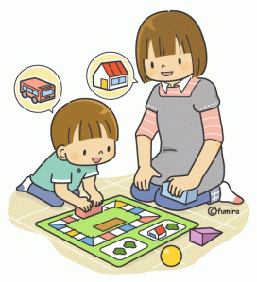

Helping your Child with Fears and Worries

Parent/Carer Group

Dear Parent/Carer,
The Emotional Support Team are offering a parent group on ‘Helping your Child with Fears and Worries’.
Reason for this course
The aim of the course is to provide parents with strategies and guidance they can use at home to support their child overcome their anxieties. The sessions are also an opportunity to reflect with one another and the facilitators on how best to apply the Cognitive Behavioural Therapies (CBT) principles highlighted in the course to help with your child’s anxiety.
This course has similar outcomes to those reported from more intense Cognitive Behavioural approaches and is aimed at children aged 5-12 who’s presenting difficulties are around anxiety.
We believe that parents are the experts when it comes to their child. You have a better understanding of how your own child might respond and what will encourage and motivate them to try different things. Parents are in the best position to support their child in between sessions and well beyond the treatment.
One of the key aims is to improve your confidence in your ability to help your child overcome their anxiety. We highlight positive skills and responses of the parent in order to build your confidence and empower you to support your child.

If you are interested in this course, please complete a request form that is held by your Senior Mental Health Lead at your school. Please complete this by Friday 2nd February 2024

Course dates
Session Number | Date | Time | Location | Course Content
1 | Wednesday 21st February | 10am-12pm | Online via TEAMS | Group introductions, Ground Rules, Philosophy of programme revisited, Psychoeducation, How anxiety develops and is maintained, treatment goals
2 | Wednesday 28th February | 10am-12pm | Online via TEAMS | What is my child thinking? What does my child need to learn? Promoting independence and having a go
3 | Wednesday 6th March | 10am-12pm | Online via TEAMS | Step-by-step plan
4 | Wednesday 13th March | 10am-12pm | Online via TEAMS | Checking in and reviewing homework, Make changes to step-by-step plan as necessary, reviewing ROMS
5 | Wednesday 20th March | 10am-12pm | Online via TEAMS | Checking in and reviewing homework, Problem solving approach, What has helped, What still needs work, Review goals
4 WEEK BREAK
6 | Wednesday 24th April | TBC | Telephone call | Individual follow up appointment – review progress: discharge, monitor or refer elsewhere

